**ASSIGNMENT NO.1.**

**Aim :-** To create ADT that implement the "set" concept.

a. Add (newElement) -Place a value into the set

b. Remove (element)

c. Contains (element) Return true if element is in collection

d. Size () Return number of values in collection

e. Intersection of two sets

f. Union of two sets

g. Difference between two sets h.Subset .

**Objective:-** to study the different set operations.

**Theory:-**

**Set** is a container implemented in C++ language in STL and has a concept similar to how set is defined in mathematics. The facts that separates set from the other containers is that is it contains only the **distinct elements** and elements can be traversed in sorted order. Having the strong hold on sets is useful in competitive programming and solving algorithmic problems. The insertion and deletion in STL sets are discussed in this article.Sets have the most impact in mathematical set theory. These theories are used in many kinds of proofs, structures, and abstract algebra. Creating relations from different sets and codomains are also an important applications of sets.

In computer science, set theory is useful if you need to collect data and do not care about their multiplcity or their order. In databases, especially for relational databases, sets are very useful. There are many commands that finds unions, intersections, and differences of different tables and sets of data.

**Program Code:-**

#include <iostream>

using namespace std;

const int MAX=50;

template<class T>

class SET

{

T data[MAX];

int n;

public:

SET()

{

n=-1;

}

bool insert(T);

bool remove(T);

bool contains(T);

int size();

void print();

void input(int num);

SET unionS(SET,SET);

SET intersection(SET,SET);

SET difference(SET,SET);

};

template<class T>

void SET<T>::input(int num)

{

T element;

for(int i=0;i<num;i++)

{

cout<<"\nEnter Element: "<<i+1;

cin>>element;

insert(element);

}

}

template<class T>

void SET<T>::print()

{

for(int i=0;i<=n;i++)

cout<<" "<<data[i];

}

template<class T>

SET<T> SET<T>::unionS(SET<T> s1,SET<T> s2)

{

SET<T> s3;

int flag=0;

int i=0;

for(i=0;i<=s1.n;i++)

{

s3.insert(s1.data[i]);

}

for(int j=0;j<=s2.n;j++)

{

flag=0;

for(i=0;i<=s1.n;i++)

{

if(s1.data[i]==s2.data[j])

{

flag=1;

break;

}

}

if(flag==0)

{

s3.insert(s2.data[j]);

}

}

return s3;

}

template<class T>

SET<T> SET<T>::difference(SET<T> s1,SET<T> s2)

{

SET<T> s3;

int flag=1;

for(int i=0;i<=s1.n;i++)

{

for(int j=0;j<=s2.n;j++)

{

if(s1.data[i]==s2.data[j])

{

flag=0;

break;

}

else flag=1;

}

if(flag==1)

{

s3.insert(s1.data[i]);

}

}

return s3;

}

template<class T>

SET<T> SET<T>::intersection(SET<T> s1,SET<T> s2)

{

SET<T> s3;

for(int i=0;i<=s1.n;i++)

{

for(int j=0;j<=s2.n;j++)

{

if(s1.data[i]==s2.data[j])

{

s3.insert(s1.data[i]);

break;

}

}

}

return s3;

}

template<class T>

bool SET<T>::insert(T element)

{

if(n>=MAX)

{

cout<<"\nOverflow.SET is full.\n";

return false;

}

data[++n]=element;

return true;

}

template<class T>

bool SET<T>::remove(T element)

{

if(n==-1)

{

cout<<"Underflow. Cannot perform delete operation on empty SET.";

return false;

}

for(int i=0;i<=n;i++)

{

if(data[i]==element)

{

for(int j=i;i<=n;j++)

{

data[j]=data[j+1];

}

return true;

}

}

//data[n--]=0;

return false;

}

template<class T>

bool SET<T>::contains(T element)

{

for(int i=0;i<=n;i++)

{

if(data[i]==element)

return true;

}

return false;

}

template<class T>

int SET<T>::size()

{

return n+1;

}

int main() {

SET<int> s1,s2,s3;

int choice;

int element;

cout<<"\nEnter number of elements in SET1:";

cin>>element;//element is used for taking size

s1.input(element);

cout<<"\nEnter number of elements in SET2:";

cin>>element;//element is used for taking size

s2.input(element);

do

{

cout<<"\n***** SET OPERATIONS *****"

<<"\n1.Insert"

<<"\n2.Remove"

<<"\n3.Search"

<<"\n4.Size of Set"

<<"\n5.Intersection"

<<"\n6.Union"

<<"\n7.Difference"

<<"\n8.Check if Subset"

<<"\nEnter Your Choice: ";

cin>>choice;

switch(choice)

{

case 1:

cout<<"\nEnter Element: ";

cin>>element;

if(s1.insert(element))

{

cout<<element<<" inserted";

}

else

{

cout<<"Insertion Failed";

}

break;

case 2:

cout<<"\nEnter Element: ";

cin>>element;

if(s1.remove(element))

{

cout<<element<<" deleted";

}

else

{

cout<<"Deletion Failed";

}

break;

case 3:

cout<<"\nEnter Element: ";

cin>>element;

if(s1.contains(element))

{

cout<<element<<" is present";

}

else

{

cout<<element<<"is not Present";

}

break;

case 4:

cout<<"\nSize = "<<s1.size();

break;

case 5:

s3=s1.intersection(s1,s2);

cout<<"\nSET 1's elements: ";

s1.print();

cout<<"\nSET 2's elements: ";

s2.print();

cout<<"\nIntersection: :";

s3.print();

break;

case 6:

s3=s1.unionS(s1,s2);

cout<<"\nSET 1's elements: ";

s1.print();

cout<<"\nSET 2's elements: ";

s2.print();

cout<<"\nUnion :";

s3.print();

break;

case 7:

s3=s1.difference(s1,s2);

cout<<"\nSET 1's elements: ";

s1.print();

cout<<"\nSET 2's elements: ";

s2.print();

cout<<"\nDifference :";

s3.print();

break;

}

}while(choice!=0);

return 0;

}

**Output Screenshots:-**

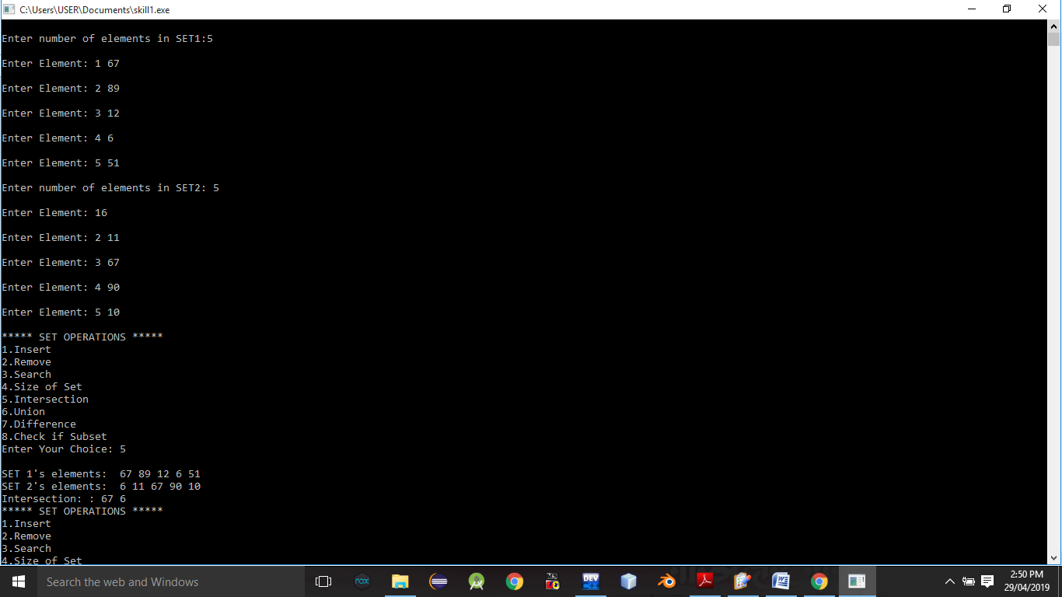

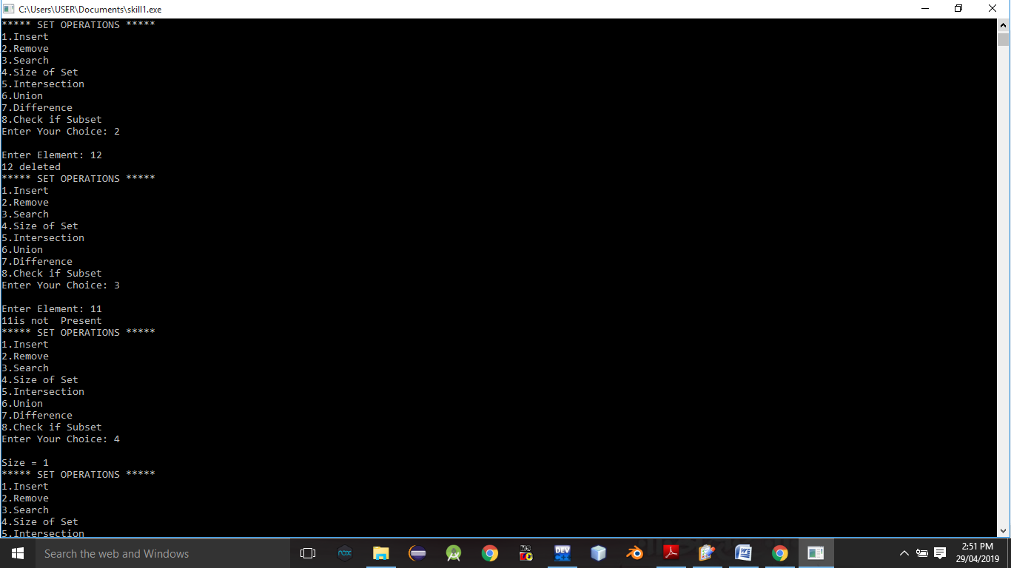

**Conclusion:-** Thus,we have studied different operations on set ADT.